Embedding Tissue for Subsequent Cryosectioning
- Pre-Embedding Notes
  - You will need the following materials:
    - OCT compound
    - Cryomold
    - Aluminum foil
    - Small & large forceps
    - Razor blade
    - Dry ice
    - Metal cutting block
    - Weigh boat
    - Isopentane (IUPAC: 2-methybutane)
    - Coolers
  - Only embed tissue from one sample at a time; multiplexing this protocol can reduce the quality of tissue.
  - Label all cryomolds with hashcode, specimen number, and heart region.
  - Cut aluminum foil into rectangles that can be used to wrap each cryomold after flash-freezing. Label each piece with hashcode, specimen number, and heart region.
  - Tissue, including sample tubes, must remain on dry ice for the entirety of this protocol.
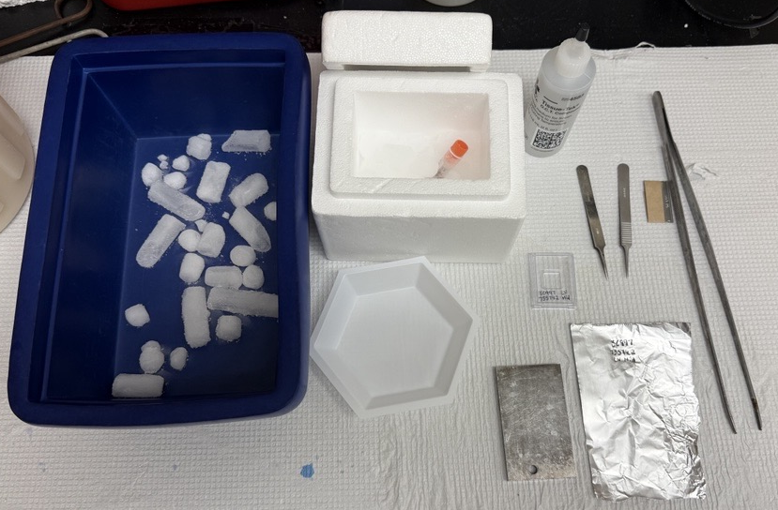
- Protocol
- Fill one cooler with dry ice and place sample tubes in it.
- Fill each cryomold halfway with OCT compound.
- Place the metal cutting block on top of dry ice in cooler, allow to equilibrate temperature for ~1 minute, then place a weigh boat on top of the metal cutting block.
- Fill another cooler with a small amount of dry ice—just enough to cover the bottom of the cooler—then fill with isopentane until the fluid level is ~2 inches above the dry ice.
- Use small forceps to pull tissue out of a sample tube and place it on the dry ice-cooled weight boat.
- Use a razor blade to excise a small ‘cube’ of tissue. Place the remaining tissue back into the sample tube.
  - The tissue should displace ~1/2 of the cryomold well.
- Use small forceps to place excised tissue into the OCT compound within the cryomold well. Use the same forceps to gently ‘push’ on the tissue to immerse it, then fill the rest of the cryomold well with OCT compound. Clamp the edge of the cryomold with the large forceps, submerge it in the dry ice-cooled isopentane for ~20 seconds, wrap it with the corresponding piece of aluminum foil, then place it on dry ice.
  - Since the tissue will be momentarily removed from dry ice, this step needs to be executed as quickly as possible.
- Store cryomolds in the -80ºC freezer.

